Annual Project Progress Report

Project title: Strenthening the Trade Capacity of Turkmenistan
Award ID: 00097116
Project ID: 00100961
Implementing partner: Ministry of Trade and Foreign Economic Relations of Turkmenistan

Period covered in this report: Jan-Dec 2020
Date of last Annual Report: n/a
Date of the last Project Board meeting: 26 August 2020

Date of last Qaulity Assurance and rating: Design and Apraisal stage in 2019, overall rating: Satisfactory

1.Project Performance

a) Please state the expected Output of the Project, set indicators and corresponding CP Outcome (as per project document/AWP):
Project Output 1: Strengthening institutional and personal trade capacity
Output indicators:
1.1 Number of specialists, who have completed certified course on professional development in the area of international trade.

1.2 Practice of concluding international trade agreements on bilateral, regional and multilateral basis
Output targets:
Target 1.1. – 30 specialists
Target 1.2. – 30 specialists

b) Were the indicators and output achieved? Yes No Partially
c) If no or partially, please explain why?
International consultant was hired to impliment Output 1.1. and IC’s contractual obligations were partially executed by IC, because of Covid-19 travel restrictions. National partner considers conduct of training in physical presense of IC. Those parts of works to be executed by IC were shifted to AWP 2021. Due to Covid-19 travel restrictions and at the national partner considerations for better quality of training, Output 1.2. was also shifted to work plan for 2021.

Project Output 2: Building capacity to formulate and impliment foreign trade-related policy measures

Output indicators:
2.1. Improving consumer market management system. International experience and recommendations for Turkmenistan.

2.2. Capacity building of national staff on application of advanced informational and marketing technologies for analyzing market and consumer behavior.
Output targets:
Target 2.1. – 30 specialists
Target 2.2. – 30 specialists

b) Were the indicators and output achieved? Yes No Partially
c) If no or partially, please explain why?
Output 2.1. was partially executed as international and national consultant were hired and desk work and training modules were carried out. However, due to Covid-19 travel restrictions within the country, at the request of national partner, arrangement of trainings were shifted to 2021 work plan. Output 2.2. was sucessfully implimented with target achievement of 31 specialists.

Project Output 3: Applied scientific research capacity has been strengthened

Output indicators:
3.1 Proposals on strengthening of research and innovation component.

Output targets:
Staff of Research Department of the Ministry of Trade and Foreign Economic Relations of Turkmenistan

b) Were the indicators and output achieved? Yes No Partially
c) If no or partially, please explain why?
Several ideas were offered to the Ministry of Trade and Foreign Economic Relations of Turkmenistan to conduct trade study research considering UNDP Regional Hubs research option and meetings with two important research institutes. Now, national partner has portfolio of potential partners for cooperation in strengthening its research capacity but the actual trade study reseach work itself shifted to 2021 work plan and therefore, Output 3.1. was partially achieved and to be completed in 2021.

2.Progress Reporting
a) Please summarize the main achievements during the project cycle:
Project Output 1:
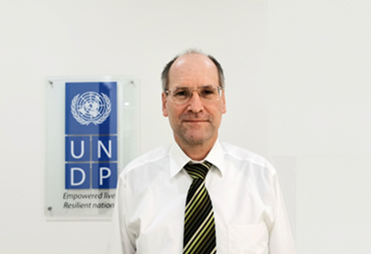
The launch of the project was with some delays as it started in late 2019 and impact of travel restrictions of new type of virus Covid-19 in 2020 greatly impacted in implimentation of planned activities for 2020 as substantial part of the project is about organizing trainings in the physical presense of international consultants. With the beginning of 2020, before exposure of covid-19 globally, as per Output indicator 1.1. international consultant from Germany Mr. Achim Seiler was contracted to assess training needs for development of trade policy formulation capacity of national trade organizations of Turkmenistan. By international consultant, trade capacity was evaluated through provision of consultations with all national project partners of Turkmenistan and assessed their needs in order to strengthen their capacity to formulate trade policy. As a result, international consultant proposed 5 days training module for Output 1.1 and training days were set. However, with travel restrictions, planned training was not delivered as per indicated targets above. Training is posponed to later dates shifiting to 2021. Visit of Mr. Achim Seiler is reflected in following press-release: https://www.tm.undp.org/content/turkmenistan/en/home/presscenter/pressreleases/2020/UNDP-and-Ministry-of-Trade-of-Turkmenistan-Kick-off-Assessment-of-Country-Trade-Capacity.html
As per approved AWP 2019-2020 Output indicator 1.2. was Capacity building of national staff on application of advanced informational and marketing technologies for analyzing market and consumer behavior and organizing sale of goods, including in velayats. In order to impliment this activity, international consultant and national consultant were hired. Both consultants provided desk work on the application of modern technology to improve domestic and foreign sales and utilization of e-marketing technologies. Training modules are set by IC with support of national consultant and provision of training either in physical presence of international consultant or in online mode was planned for 75 participants from 5 velayats. At the request of national partner training for velayat specialists was shifted to early next year.
For national trade organizations: Ministry of Trade and Foreign Economic Relations of Turkmenistan, State Commodity and Raw Materials Exchange of Turkmenistan, Chamber of Commerce and Industry of Turkmenistan and Union of Industrialists and Entrepreneurs of Turkmenistan, trade policy development needs were assessed through consultations. Based on needs assessment training modules were determined by international expert.

Project Output 2:
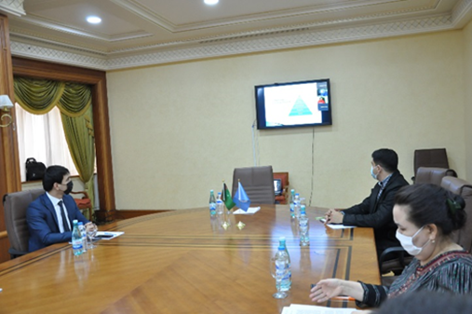
As per Output 2.2., international consultant with many years of capacity development experiences within international organizations and governments, Mr. Ravinder Raina national of Canada was contracted along with national consultant. IC provided a desk work for identifying best international practices on the application of advanced informational and marketing technologies. In semi-online mode, training was delivered from 23 – 27 November 2020 in physical presense of majority of participants in the Trade Complex Building of Turkmenistan in Ashgabat city. Total number of participants were 31 specialists mainly from the Ministry of Trade and Foreign Economic Relations of Turkmenistan, State Commodity and Raw Materials Exchange of Turkmenistan, Chamber of Commerce and Industry of Turkmenistan, Union of Industrialists and Entrepreneurs of Turkmenistan, and Ministry of Finance and Economy of Turkmenistan. Participants were aquainted with basic modern marketing concepts and techniques and application of advanced technologies in trade and commerce. National trade specialists learned international practices, trends and developments in e-commerce and how to develop e-commerce at individual firm and national levels. Online training was in interactive form with questions and answers sessions.
As approved in AWP 2019-2020, Development of proposals on elimination of trade barriers and implimentation of comprehensive system to support national export throughout the whole goods shipment chain; International experience and recommendations for Turkmenistan, national partner advised to conduct this activity in physical presense of international consultant in the hope that travel restrictions will be lifted in 2021. Therefore, the activity was shifted to 2021.

31 trade officials from Ashgabat city mainly from Ministry of Trade and Foreign Economic Relations of Turkmenistan, State Commodity and Raw Materials Exchange of Turkmenistan, Chamber of Commerce and Industry of Turkmenistan, Union of Industrialists and Entrepreneurs of Turkmenistan, and Ministry of Finance and Economy of Turkmenistan were trained with application of advanced infomrational and marketing technologies along with modern marketing concepts and techniques.

Project Output 3:
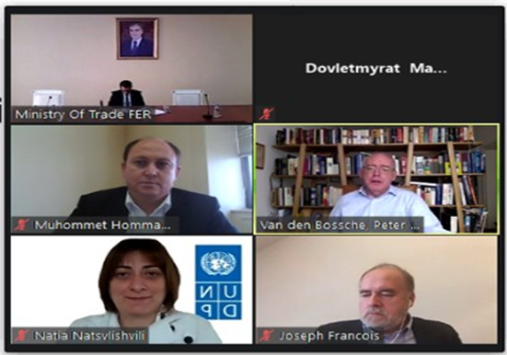
To achieve results for Output 3.1. professional research organization was searched to establish potential partnership with the Research Department of the Ministry of Trade and Foreign Economic Relations of Turkmenistan. Online consultations were held with Istanbul Regional Hub of UNDP and Trade Specialist of UNDP Kyrgyzstan. Also within the Project Document it is proposed to make portfolio of potential expert organization to arrange cooperation in trade research with national partner, respective online meetings and consultaions were held between World Trade Institute of Bern, Switzerland on October 8, 2020 (for reference: https://www.tm.undp.org/content/turkmenistan/en/home/presscenter/pressreleases/2020/UNDP-and-the-Ministry-of-Trade-establish-partnership-with-WTI.html ) and with National Research University Higher School of Economics of Russian Federation on December 15, 2020 (for reference: https://www.tm.undp.org/content/turkmenistan/en/home/presscenter/pressreleases/2020/UNDP-supports-Ministry-of-Trade-of-Turkmenistan-to-expand-its-partnership-network.html ). Online meetings were attended by representatives of Research and Foreign Economic Relations Departments of the Ministry of Trade and Foreign Economic Relations of Turkmenistan, UNDP and respective foreign expert organizations. During the online meetings, questions and answers were exchanged to explore potential in the area of trade research cooperation.

Potential cooperation in trade research field between the Ministry of Trade and Foreign Economic Relations of Turkmenistan and globally and regionally well recognized research institutes were arranged and explored.

3. Project Risks and Issues

The project Risk Log is maintained throughout the project implementation to capture potential risks to the project and associated measures to mitigate risk.The Project Manager shall maintain and update the Risk Log and ensure that risks are identified, communicated and managed effectively.

A number of potential risks are listed below.

Description of risk | Type and category | Risk management actions | Current situation
Slight lagging in implementation of 2019 targets behind the schedule as per approved AWP | Low risk level | Concerns were raised during Project Board meetings in 26 February and 26 August in 2020 | Project was extended until 31/12/2021
Non payment of due 102,714 USD (2nd USD installment) to UNDP Turkmenistan account as per ProDoc | Low risk level | Speeding up payment of second USD installment was requested during Project Board meeting in 26 August 2020 | Ongoing
Slow implementation of project activities and risk of catching up with targets | Moderate risk level | Project was submitted for extension until 2021 and it is granted. Approved project activities will be delivered through AWP 2021 | Ongoing

4.Lessons learned and follow-up steps (if applicable)
a) Please provide the lessons learned and further steps after the project’s closure.

- Ministry of Trade and Foreign Economic Relations of Turkmenistan is a new national partner with UNDP. As substantial part of our project was designed strengthening the institutional and human capacities of trade sector in Turkmenistan and considering covid-19 restrictions Ministry has restricted provision of online trainings. As international communities move on with digitalization, more efforts are required to bring best international practices in utilization of modern communication technologies and techniques for training specialists of trade complex of the country. It is required to adapt more methods of e-training taking local conditions into account.
- As Turkmenistan set an ambition to join WTO it was granted with an observer status to the organization. Hence, design of project and provision of corresponding trainings could be in line with strengthening the trade capacity of Turkmenistan that give sufficient knowledge to prepare for WTO membership along with capacity development.

5.Transfer of Assets or other related matter
a) Please state on any past or future transfer of assets made within the project cycle (Attach list of equipment, cooperation frameworks with beneficiaries, etc.)

⃰ Please refer to attached annex I. Asset List for Trade Project.
7.Financial management
Budget item | Total approved in 2020 (in USD) | Expenses + commitments | Budget utilization in % to planned
Component 1 | 81,677 | 79,367 | 97.17%
Component 2 | 13,550 | 7,991 | 58.97%
Component 3 | 9,234 | 465 | 5.04%
Project management | 27,777.57 | 29,552 | 106.39%
Total delivery in 2020 | 104,461 | 87,823 | 84.07%
In % to total project budget | 468,175 | 104,461 | 22.31%

Prepared by: Muhommet Hommayev, Project Specialist

Date: 27/12/2020

Approved by: Akmyrat Danatarov, Programme Analyst

Date:30/12/2020

